Pattern | Next Figure | Table of Values | Formula | Type?
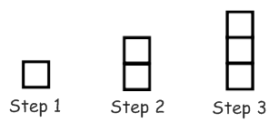 |  | Step # # of Squares  (n) f(n) | Recursive:  Explicit: | Linear ____  Quadratic ____  Exponential _____
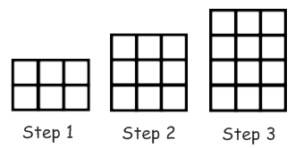 |  | Step # # of Squares  (n) f(n) | Recursive:  Explicit: | Linear ____  Quadratic ____  Exponential _____
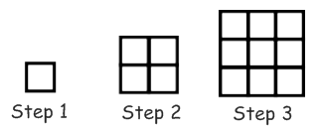 |  | Step # # of Squares  (n) f(n) | Recursive:  Explicit: | Linear ____  Quadratic ____  Exponential _____
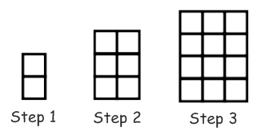 |  | Step # # of Squares  (n) f(n) | Recursive:  Explicit: | Linear ____  Quadratic ____  Exponential _____
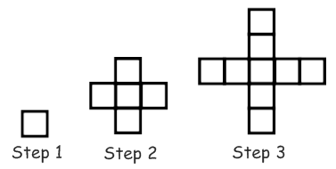 |  | Step # # of Squares  (n) f(n) | Recursive:  Explicit: | Linear ____  Quadratic ____  Exponential _____
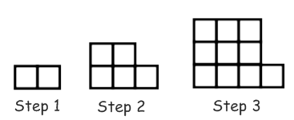 |  | Step # # of Squares  (n) f(n) | Recursive:  Explicit: | Linear ____  Quadratic ____  Exponential _____
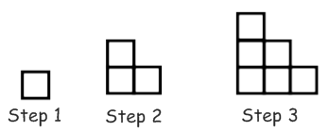 |  | Step # # of Squares  (n) f(n) | Recursive:  Explicit: | Linear ____  Quadratic ____  Exponential _____
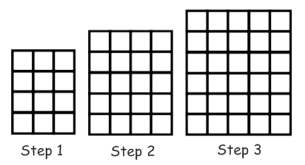 |  | Step # # of Squares  (n) f(n) | Recursive:  Explicit: | Linear ____  Quadratic ____  Exponential _____

