Name: __________________________________________________ Date: ____________ Period: _____

Practice Quiz 2.1-2.3

Please simplify the following.
- $\sqrt{x^{4}y^{2}}$ | - $\sqrt{36x^{6}y^{20}}$
Use the graph to answer the following questions.  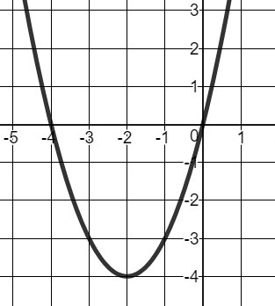 | - Find the vertex of the above graph. Be sure to write as an ordered pair.
 | - Find the axis of symmetry. Be sure to write it in the correct form.
 | - List the x-intercepts. Be sure to write as an ordered pair.
 | - List the y-intercept. Be sure to write as an ordered pair.
- Write the equation of the above function in vertex form. | - Use the equation $f\left(x\right)={6x}^{2}-7x-5$ to identify the following.  - _____________  - _____________  - _____________
- Change the following into standard form.  $$f\left(x\right)=\left(2x+1\right)\left(3x-5\right)$$ | - Graph the following equation.  $$f\left(x\right)= {(x-2)}^{2}-3$$  