Name: __________________________________________________________ Date: ________________
1.7 Homework

Simplify the following expressions.

- $(3x -5) – (2x + 2)$ | - $\left(x+5\right)+\left(2x-7\right)$ | - $(x + 4)+(2x -4) –(5x +1)$
- $(x + 2)(3x -4)$ | - $(3x -5)(2x +2)$ | - $(x+5)(2x-7)$

Evaluate the following functions for f(-1), f(0), and f(3).
- $f\left(x\right)= -2x+6$ | - $f\left(x\right)=3*2^{x}$ | - $f\left(x\right)= x^{2}+3x+2$
- $f\left(x\right)= \frac{1}{2}x-\frac{3}{2}$ | - $f\left(x\right)=2*{(-3)}^{x}$ | - $f\left(x\right)= -{2x}^{2}+3x-5$

For each of the following representations of a given function please state if it is Linear, Exponential, Quadratic or None.

13.  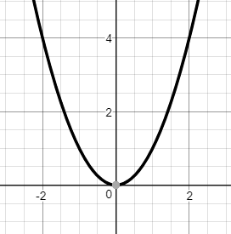 | 14.  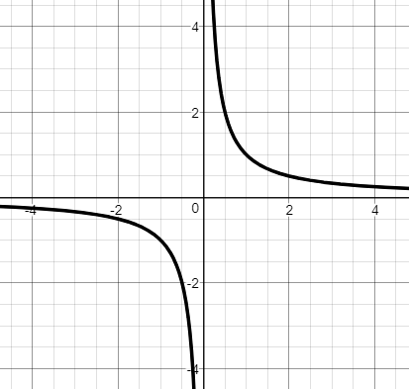 | 15.  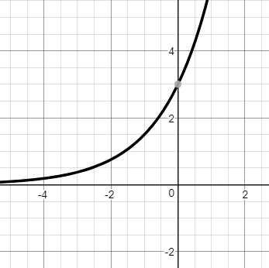
16. $f\left(x\right)= \frac{1}{2}x-\frac{3}{2}$ | 17. $f\left(x\right)=2*{(-3)}^{x}$ | 18. $f\left(x\right)= -{2x}^{2}+3x-5$
19.  $$x$$ $$y$$  -1 3  0 5  1 7  2 9 | 20.  x -1 0 1 2  y 1 2 4 8 | 21.  $$x$$ -1 0 1 2  $$y$$ 0 -1 0 3

Look at the following pattern. Create a TABLE. Identify the type of function (Linear, exponential, or quadratic). Write the recursive and the explicit equation.

1
2
3

